22.26: a) At a distance of 0.1 mm from the center, the sheet appears “infinite,” so:
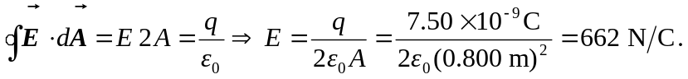
b) At a distance of 100 m from the center, the sheet looks like a point, so:
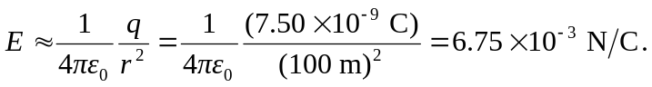
c) There would be no difference if the sheet was a conductor. The charge would automatically spread out evenly over both faces, giving it half the charge density on any as the insulator 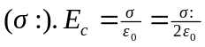 near one face. Unlike a conductor, the insulator is the charge density in some sense. Thus one shouldn’t think of the charge as “spreading over each face” for an insulator. Far away, they both look like points with the same charge.

